

**UNIVERSITY OF PETROLEUM & ENERGY STUDIES**

**SCHOOL OF COMPUTER SCIENCE**

***Department of Cybernetics***

**GRAPHICS AND ANIMATIONS TOOLS**

LAB FILE

SESSION(2020-21)

Course: BTech with specialization in Open Source & Open Standards

Submitted to: Submitted by:

Dr. Durgansh Sharma Surabhi Kumari

Associate Professor SAP: 500063663

Department of Cybernetics Roll no: R100217101

**Experiment-7**

Design of Rocket using Blender

1. Open Blender

2. Create a blank file and delete the default cube.

3. Make a sphere with the help of Ctrl+3.

4. Give it a smooth shade with shade smooth property.

5. Give the sphere a oval shape.

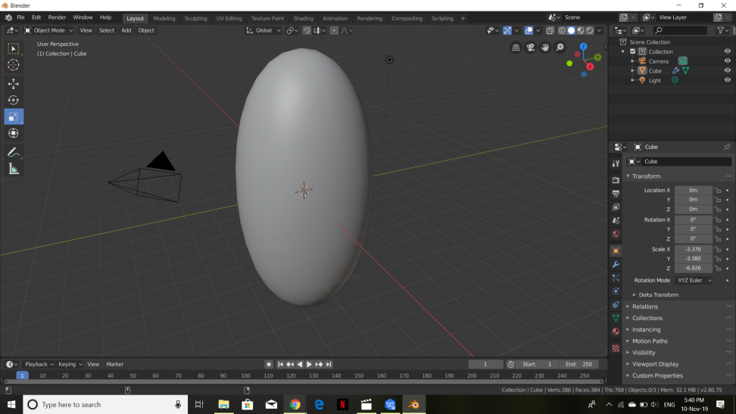

6. Enable the face mode and scale all the faces accordingly.

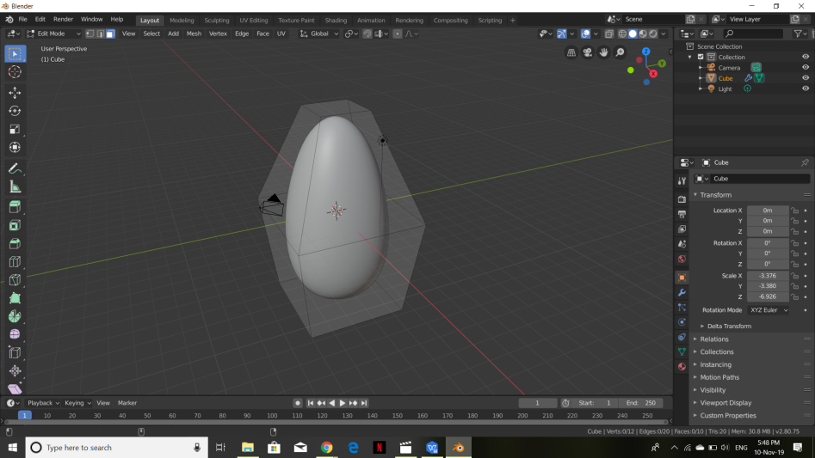

7. Shaping the main rocket without legs accordingly.

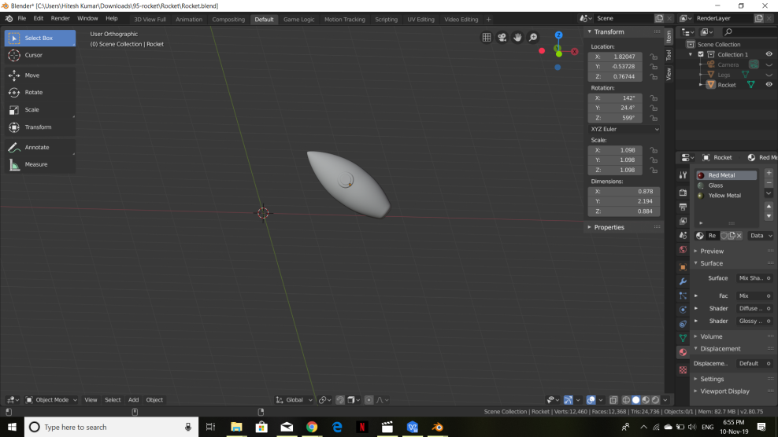

8. Making legs for the main model.

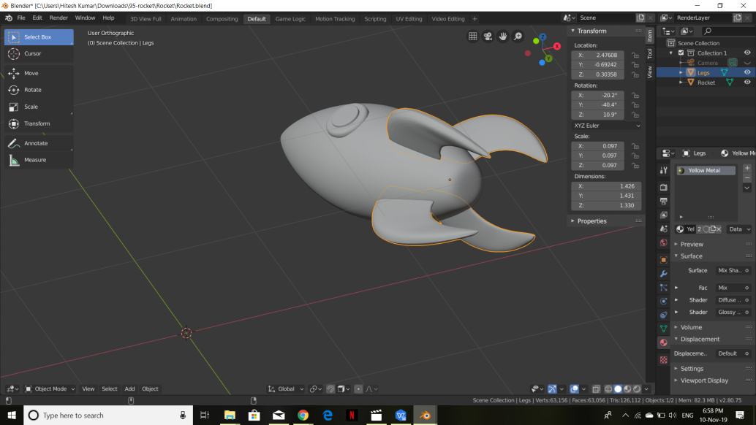

9. Making the final joint model.

10. Select material, and add base color, eventually assigning the particular material and base color to the object.

11. Now add a camera and a light source to it. And arrange the camera to the best fit view.

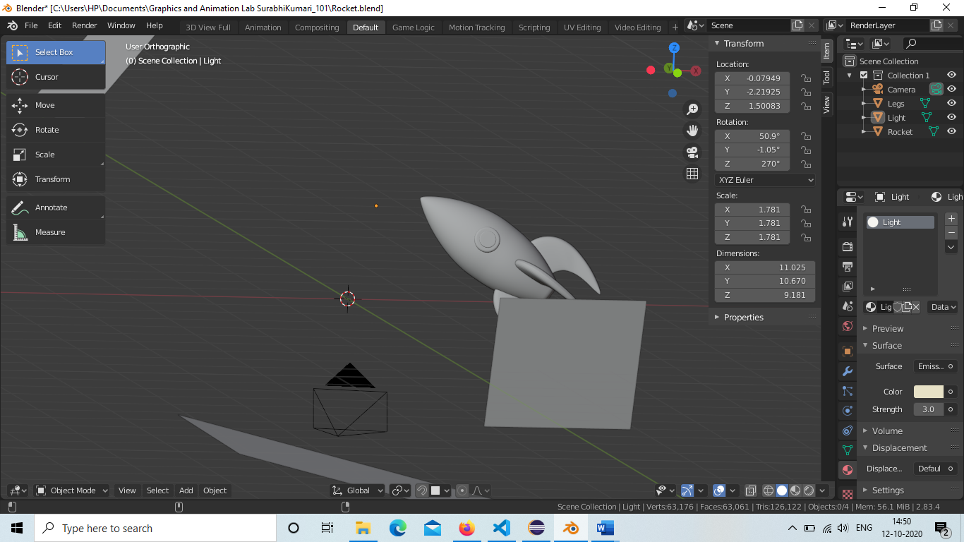

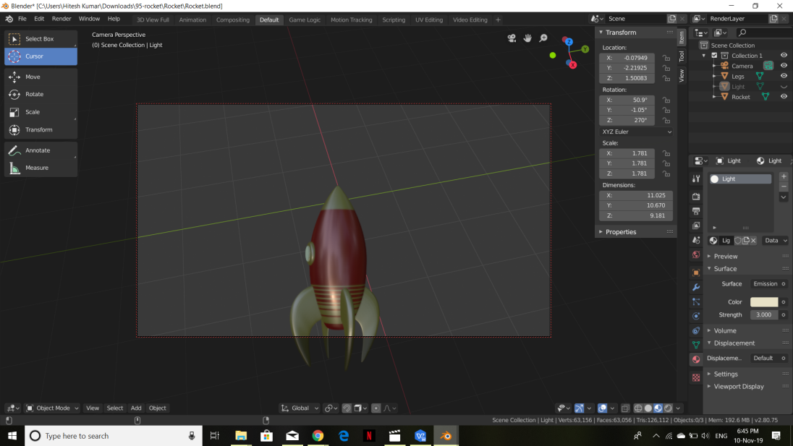

[**Link of Experiment**](https://drive.google.com/drive/folders/12AU6rSqGdDFuq8QcYxVUSwTfPH2qgBw-?usp=sharing)